Test Document

Manual Testing

|  |  |
| --- | --- |
| User Story | General – Applies to All |
| Test Case ID | 1 |
| Description | Server is unavailable |
| Preconditions | 1. Apache is not running 2. The browser is open |
| Actions | 1. The address ‘http://localhost/TekkenApp/’ is entered in the browser |
| Expected Results | 1. The page does not load 2. A 404 is displayed on the browser |
| Test Status | Passed |

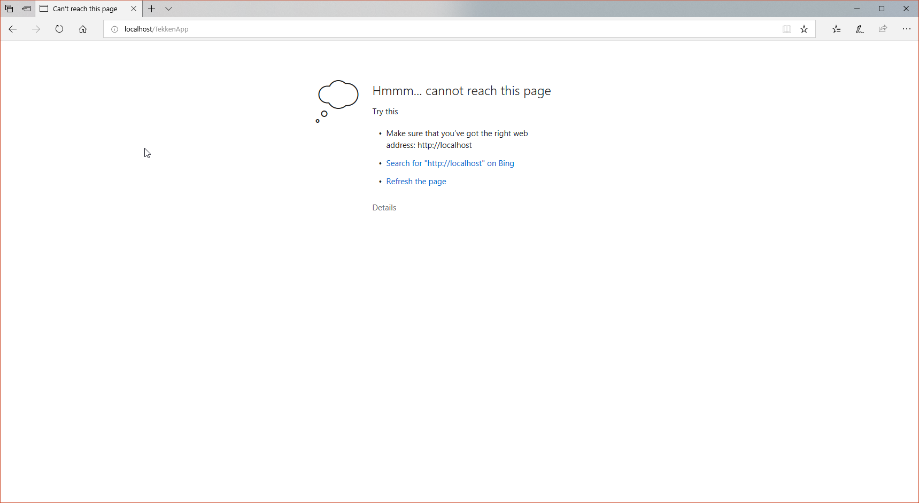

|  |  |
| --- | --- |
| User Story 1 | As the manga admin, I want to display a fighter datatable, so that users are aware of all available fighters. |
| Test Case ID | 2 |
| Description | View a datatable |
| Preconditions | 1. Apache is running 2. The browser is open 3. The database is available |
| Actions | 1. The address ‘http://localhost:80/TekkenApp/’ is entered in the browser |
| Expected Results | 1. The page loads 2. The datatable is displayed with all entries. |
| Test Status | Passed |

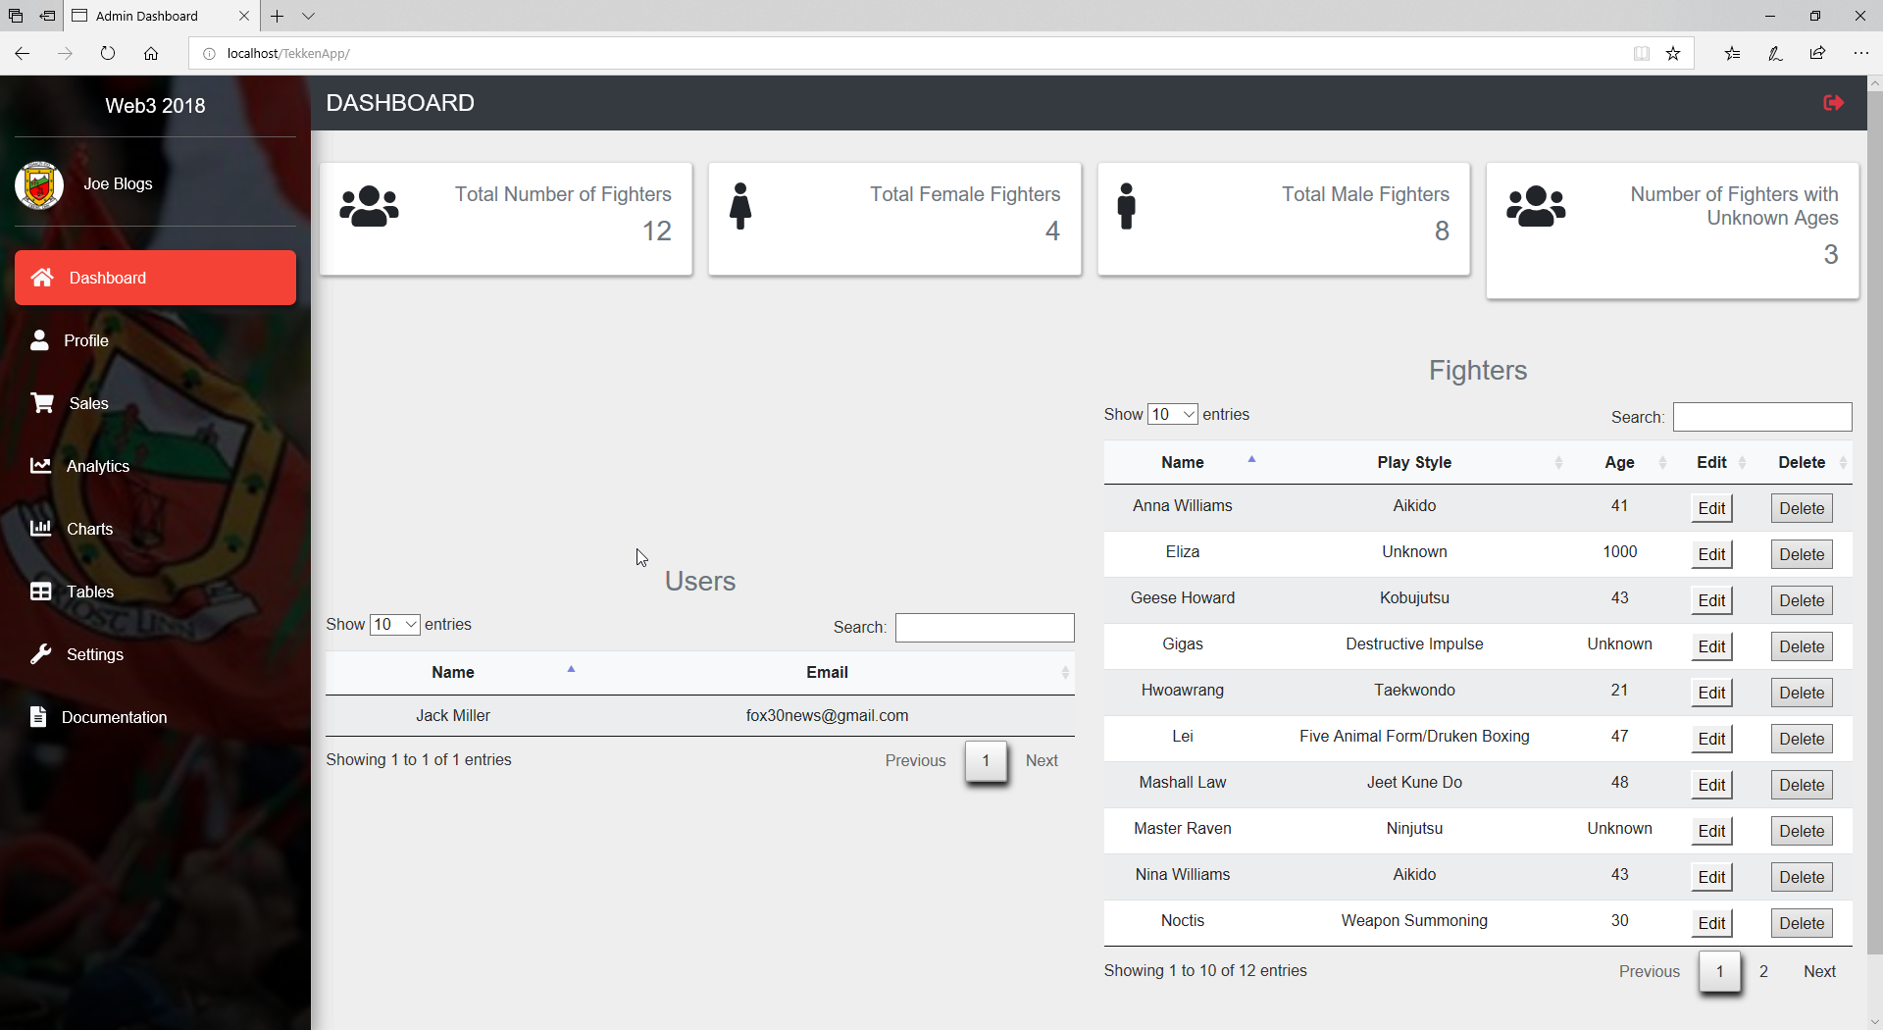

|  |  |
| --- | --- |
| User Story 1 | As the manga website owner, I want to display a fighter datatable, so that users are aware of all available fighters. |
| Test Case ID | 3 |
| Description | View a datatable |
| Preconditions | 1. JApache is running 2. The browser is open 3. The database is not available |
| Actions | 1. The address ‘http://localhost:/TekkenApp/’ is entered in the browser |
| Expected Results | 1. The page loads 2. The datatable is displayed with no database contents and a message that the database cannot be accessed |
| Test Status | Passed |

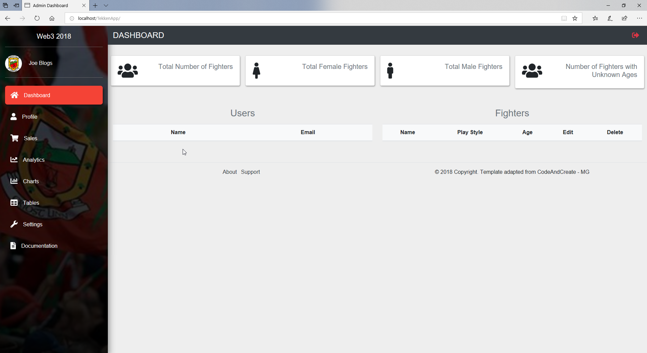

|  |  |
| --- | --- |
| User Story 2 | As a website user, I want to be able to filter a datatable, so that I can view relevant fighter entries. |
| Test Case ID | 4 |
| Description | Filter a datatable |
| Preconditions | 1. Apache is running 2. The browser is open 3. The database is available |
| Actions | 1. The address ‘http://localhost:/TekkenApp/’ is entered in the browser 2. ‘Anna’ is typed in the search bar |
| Expected Results | 1. The page loads 2. The datatable is displayed with all entries and then filtered down to display the single fighter entry for ‘Anna’ |
| Test Status | Passed |

